

WWW.gelliprimary.org.uk

Gelli Primary School Prospectus
2026-2027
The future is in our hands
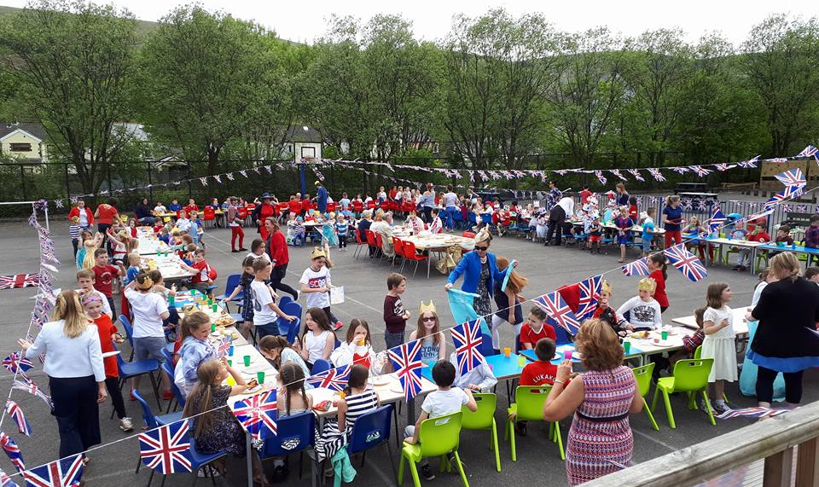

Croeso I Ysgol Gynradd Gelli
Ystrad Rd, RCT CF41 7PX (01443 435311)
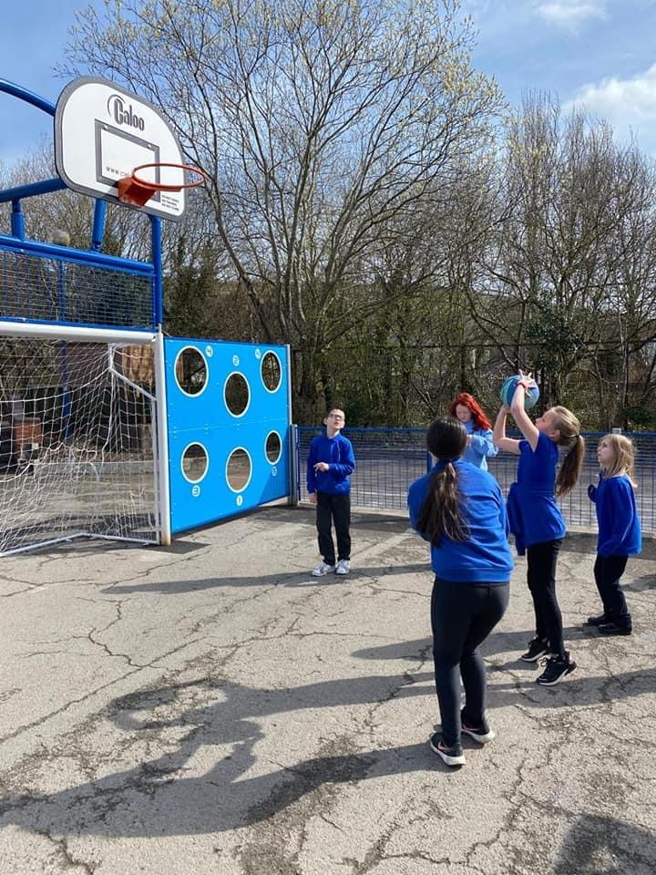
Croeso, Welcome
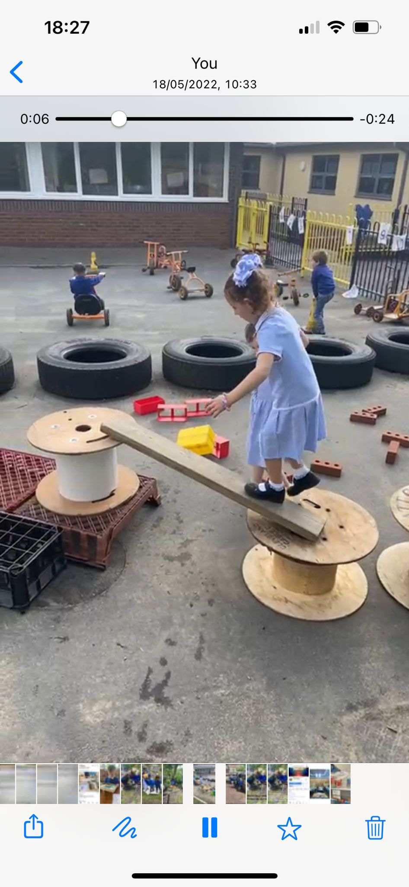
I am delighted that you are considering Gelli Primary School, a school committed to delivering excellence. We are committed to not only ensure that our children are safe and happy but our experienced team are fully committed to delivering a curriculum that is full of authentic, engaging experiences to ensure that our children can develop and acquire the skills and knowledge they need to become lifelong learners and informed citizens.
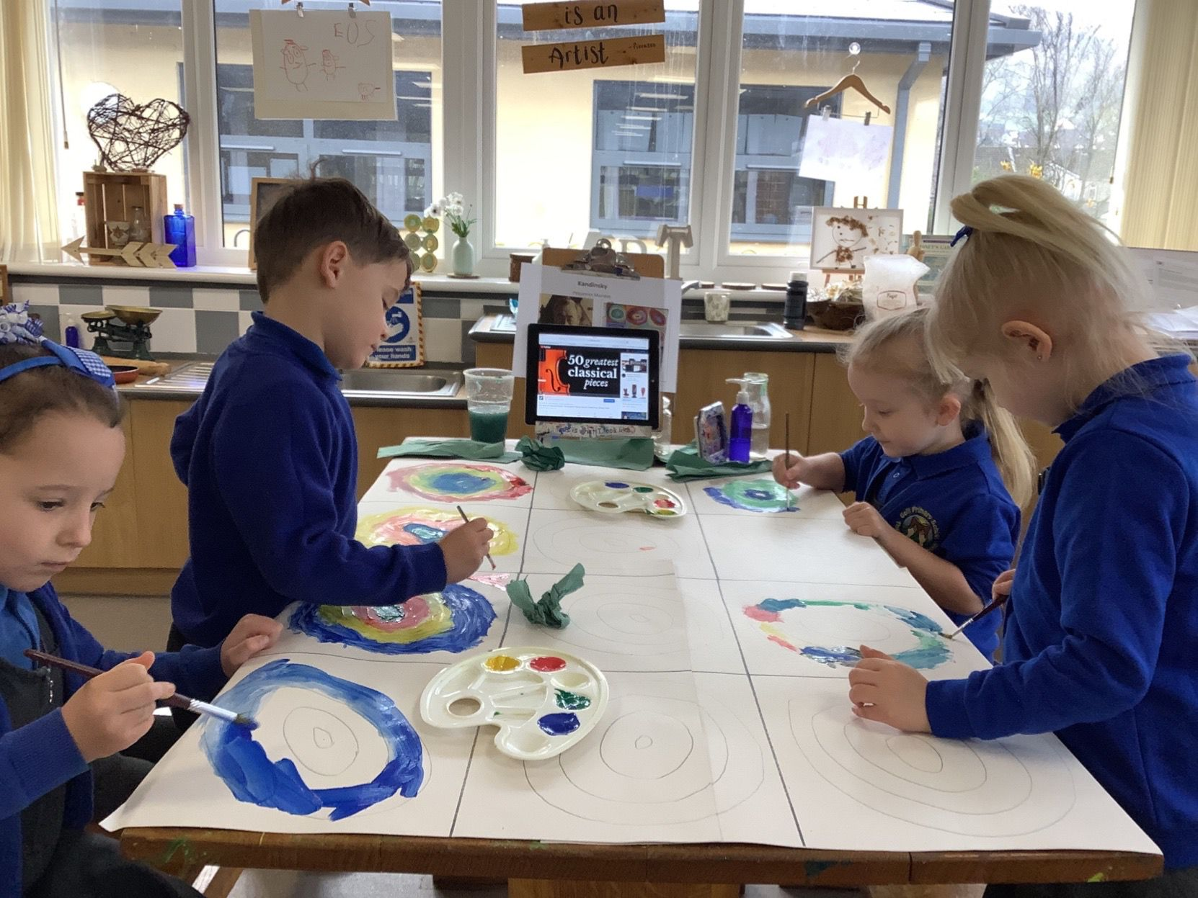
We are a restorative school as we believe every child should be heard and we want all of our learners to have the correct tools in order to amend relationships with one another. We aspire to build positive relationships with all students based on trust and mutual respect. Our family engagement officer is also at hand to provide support and guidance to our pupils and their families. Our inclusive and supportive approach ensures that all children settle in well and our experienced
ALNCo ensures that our children have the right level of
support in order to flourish.

Parents are always welcome in school. Please do not hesitate to contact me on any aspect relating to this Prospectus or any other matter pertaining to the education and well being of your child at Gelli Primary School.

Gelli Primary School is a very happy and welcoming place to be and we are extremely proud of our school and our community. We look forward to meeting you and working in partnership to give your child the very best school experience.
Diolch,
Mrs Flanary Davies, Headteacher
Staffing at our school
Head teacher | Mrs. C. Flanary Davies
Deputy Headteacher | Mrs. K. Adams
ALNCo | Mrs. A. Fraser

 | Teaching staff | Support staff
Dosbarth Gelli | Ms. C. Mathias | Mrs. K. Jones  Miss. K. Eggar & Mrs R Pope
Dosbarth Treorci | Mrs. K. Dyer | Miss Hayden
Dosbarth Pontypridd | Mrs. G. Dyer | Mrs Resoli
Dosbarth Aberhonddu | Mrs Fraser | Mrs. L. Goodwin
Dosbarth Caerdydd | Mrs. L. Johnson | Miss Dowling
Dosbarth DYP | Mrs. K. Adams
Dosbarth Eryri | Mrs. C. Pugh

Chair of Governors | Mrs. D. Jouvenat

Local Authority Reps | Councillor. W. Lewis, Mrs. D. Jouvenat
Headteacher Rep | Mrs. C. Flanary Davies
Teacher Reps | Mrs, L, Johnson, Miss C Dowling
Parent Reps | Mrs. L. Phillips, Mrs. S. Gregory
Community Reps | Mrs. N. Jackman, Mrs. N Summerhill

School Secretary | Miss L Daniel
Site Manager | Mr. C. Jones

School cook/assistant cook | Mrs Riddiford & Mrs Timmons
Kitchen Assistant | Ms Evans
Lunchtime Supervisors | Mrs Bevan, Mrs Evans , Mrs Southcombe,

Facilities at our school
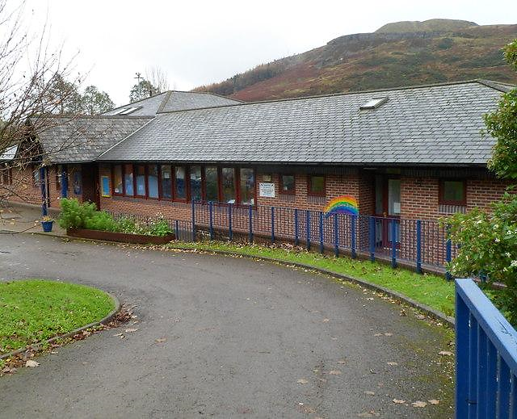

Gelli Community Primary School is maintained by Rhondda Cynon Taf and the director of Education catering for the needs of pupils from three to eleven years of age. The school building has been recently extended and refurbished to a high standard. We are very proud of the learning environment we have developed in line with research and pupil voice. You will see learning using natural materials such as loose parts, and wood to encourage curiosity, provoke creative choices and open-ended play.
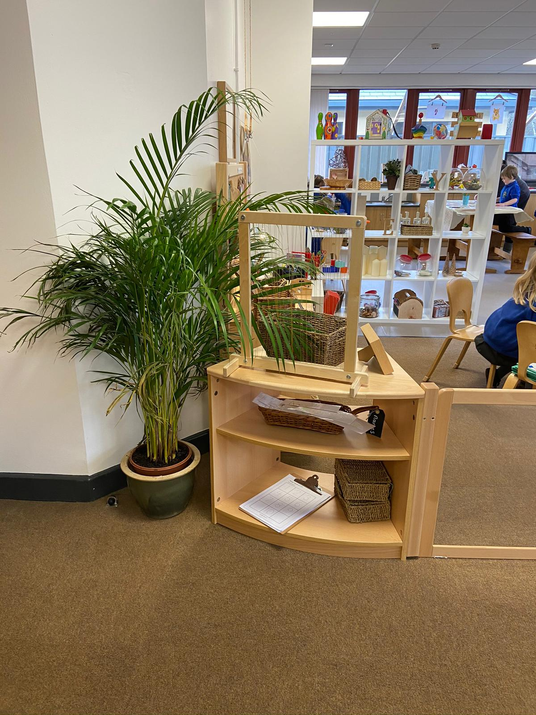
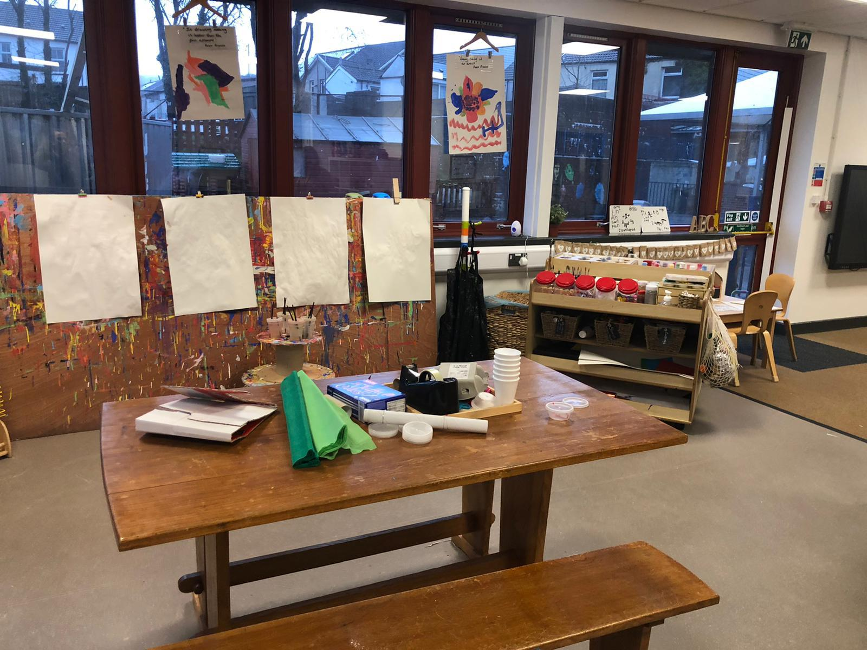
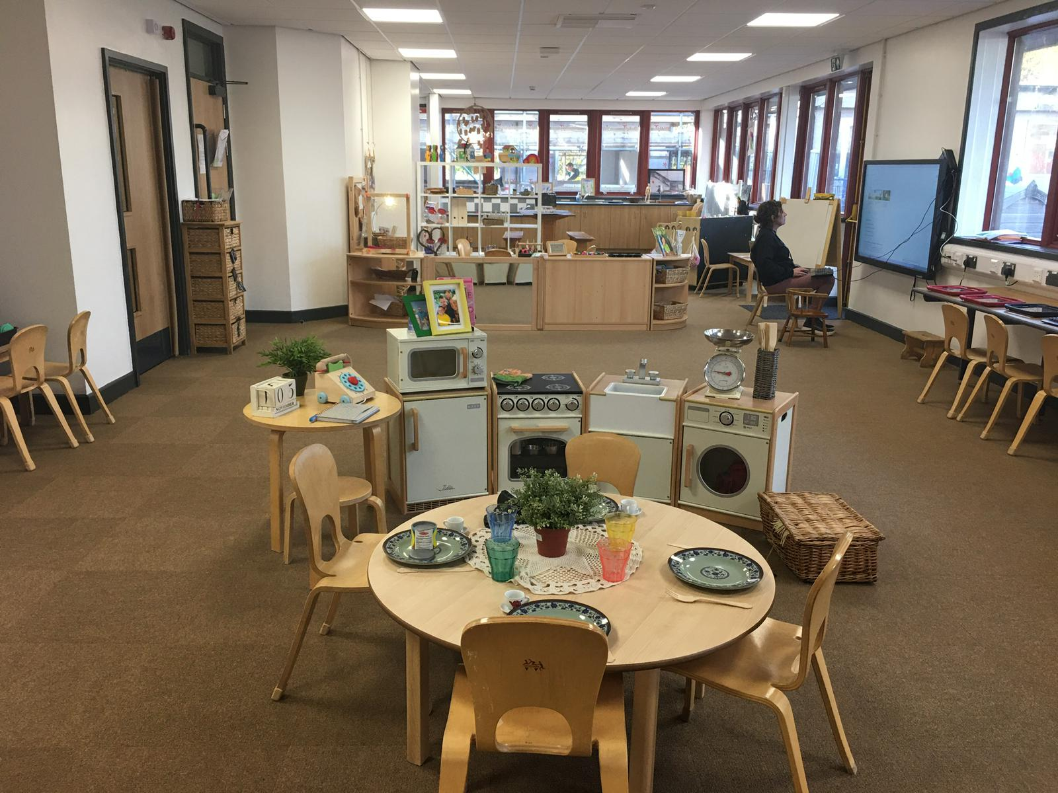

Every classroom is age appropriate and fosters independent learning and collaboration and both supports and enhances learning.
The classroom environments are child-centered and you will see children working on the floor, individually at a table, on high tables and stools or in small groups
Over the last few years the school has worked tirelessly to ensure it is fit for 21st century learning. Currently the school has:
- Ipads in every classroom
- Enhanced technology in breakout areas
- Interactive screens
- Breakout outdoor learning areas
- A new Multi-use games area (MUGA)
- A “Big Bocs Bwyd
- A family engagement officer
Facilities at our school

What is the Big Bocs Bwyd?
Our onsite shop is called Y Pantri. Every week, we collect food that may be nearing the end of its best before date, is surplus or had a change in packaging and it is available three days a week in our Y Pantri shop. The shop is run by volunteers and has a Pay As you feel donation system. Y Pantri is also open to community members. The purpose of Y Pantri is to reduce food waste and we would love you to visit and see the range of products available. We publicise the stock in Y Pantri weekly through our social media accounts.



Who is our Family Engagement Partner?

Miss Hatch is our family engagement partner, please see her if you have any questions or concerns. You will see Miss Hatch either on the school gate or please ask reception for her. She is part of a network of community partners and she may be able to signpost you to the support you can access within school and within our community.

In school Miss Hatch works to deliver bespoke wellbeing sessions to our pupils. These are tailored to meet your child’s needs within a group or individual setting offering a range of strategies to promote attendance, increase in participation, engagement and achievement.

School life
Our vision statement “Always believe, Always Achieve,
Learn, grow, play towards our hopes and dreams”

Gelli Primary is committed to creating and delivering a curriculum accessible to all based on three aspects of curriculum design: the “Why, How and What”.
WHY? As a school we have developed a curriculum that offers children a voice in the planning to ensure that our learners are fully engaged to develop responsibility and independence.
HOW? We offer our learners a mix of discrete and inquiry-based teaching and learning that starts by getting our pupils to pose questions and engages our pupils by making real life connections.
WHAT? Our curriculum is based on the four purposes. Our curriculum is designed to ensure our children are:

- Ambitious Capable Learners
- Enterprising Creative Contributors
- Ethical Informed Citizens
- Healthy Confident Individuals

Gelli Primary also ensures that our learners have a curriculum that is progressive and one in which they will experience equal weighting of the 6 areas of learning.
Our curriculum is based around the progression, coverage and development

of the 27 What Matters Statements within these Areas of Learning and Experience. Assessment is then used to drive attainment in these areas for individuals and groups of learners.

We pride ourselves on the high standards achieved here, across the curriculum. This is verified by the quality of the children’s work, by their attitude and by their achievements. To achieve this we rely upon close co-operation between home and school.

The ALNCo supports staff to identify any additional learning needs that may be a barrier to learning. A pupil centered meeting will take place to discuss these barriers and an appropriate support plan will be put into place. This could be in the form of a learning passport or an individual educational plan.

The role of assessment in Gelli is to support individuals on an ongoing, day-to day basis, identify, capture and reflect on individual learners' progress over time and to deepen understanding on group progress to reflect and refine practice.

Our school structure:
Progression step 1 | Nursery  Reception | Dosbarth Gelli  Dosbarth Gelli
Progression step 2 | Year 1  Year 2  Year 3 | Dosbarth Treorci  Dosbarth Pontypridd  Dosbarth Aberhonddu
Progression step 3 | Year 4  Year 5  Year 6 | Dosbarth Caerdydd  Dosbarth Dinbych  Dosbarth Eyri

Progression step 1
The Foundation Phase is vitally important, as it lays strong foundations for further development. Parents play a particularly important part at this stage of their child’s education, and strong partnerships and communication are encouraged between school and home. The focus within this progression step is to develop a feeling of Cynefin (belonging) to our school, family and community and this is then further developed throughout the school.
A strong emphasis is placed at this stage on the acquisition of language skills and personal and social skills. All nursery pupils are able to access the curriculum for funded non maintained nursery settings. Reception children access Curriculum for Wales

Progression step 2 and 3
All subjects are taught through inquiries and literacy, numeracy and digital Competency skills are developed discreetly and through the inquiries. The development of ICT skills is important, so pupils can use these skills effectively to support their learning across the curriculum.

Discrete teaching
Discrete teaching is stand alone learning or the teaching of skills. In our school this is
often the teaching of the skills of English and Maths, Welsh and an additional language, RE, PE , ICT and any aspect of the curriculum at the teacher’s discretion.

Inquiry Based Learning
Inquiry based learning is a mixture of directed, facilitated and independent learning that starts with a question or statement. This question or statement takes the learner on a learning journey that can be part directed by the teacher and part self-directed by the learner.

Healthy eating

We have been awarded our ‘Healthy Schools’ accreditation. In progression step 1 and 2 we provide our children with a daily healthy snack and we ask families to support this by paying £1.00 per week. Children in Nursery, Reception, Year 1 and Year 2 will receive a free carton of milk during snack time. Pupils are encouraged to bring healthy snacks to school. As we are a healthy school we ask that no chocolates, sweets or crisps are eaten during break times. Fizzy drinks are also not permitted. Research has shown that children’s concentration is improved if they drink water regularly. Therefore, we encourage pupils to bring bottles to school so that they can be filled.
At our school there is a full programme of extra-curricular activities and pupils are encouraged to participate in this important part of school life. The aim is to build confidence by allowing pupils to have new experiences and also to take on leadership roles.
The extracurricular and enrichment activities offered by the school include:
● Rugby ● Football
● Athletics ● Swimming
● Pupil voice ● Cardiff city football tuition
● Breakfast club ● Residential trips
● Various committees ● Cluster sports
● Local matches
● The Senedd

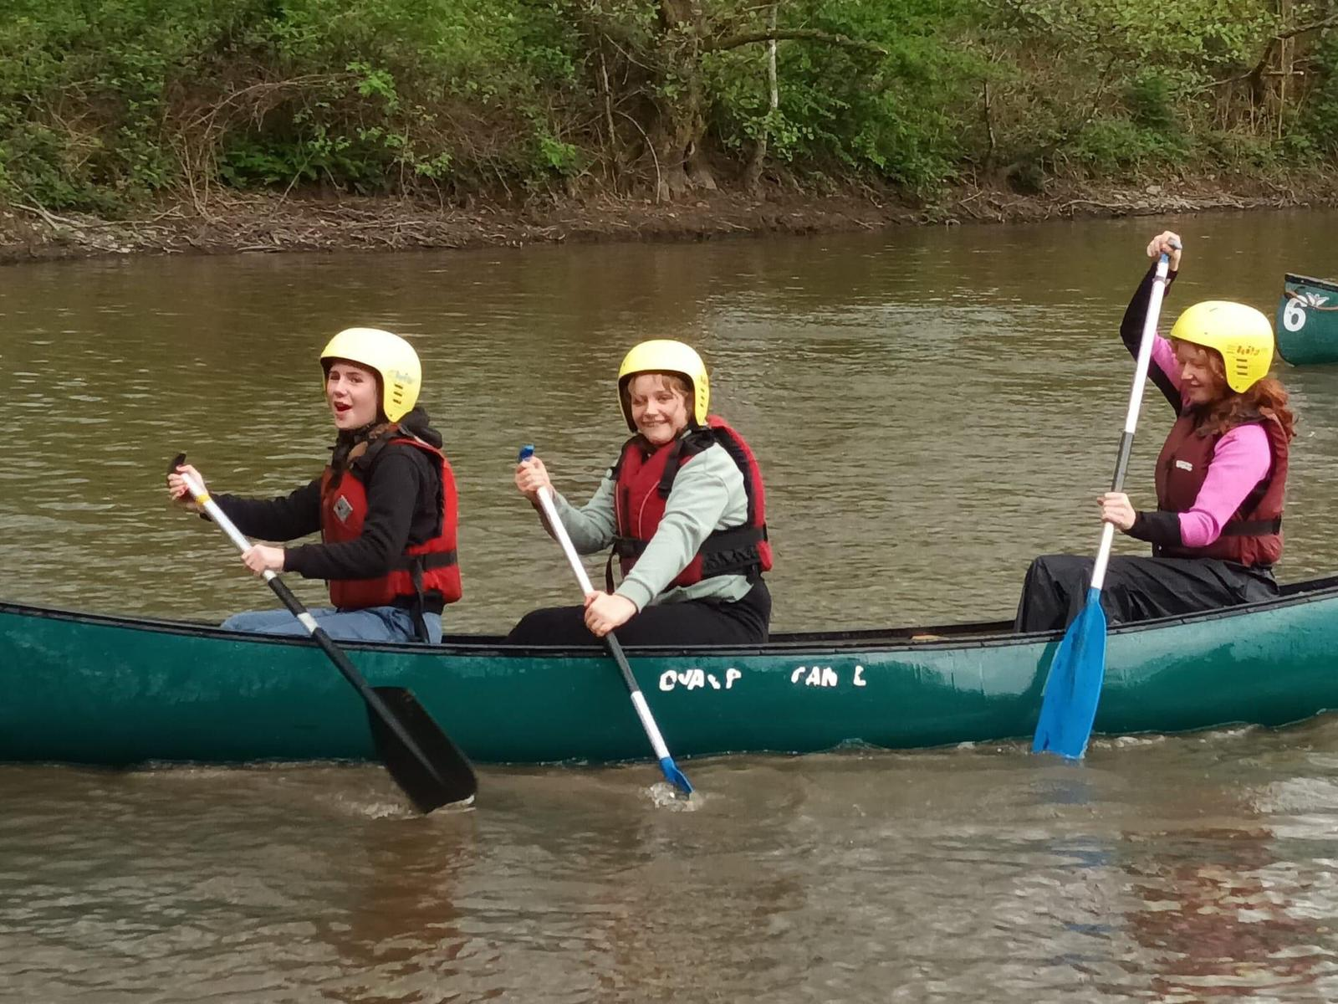
- Rugby
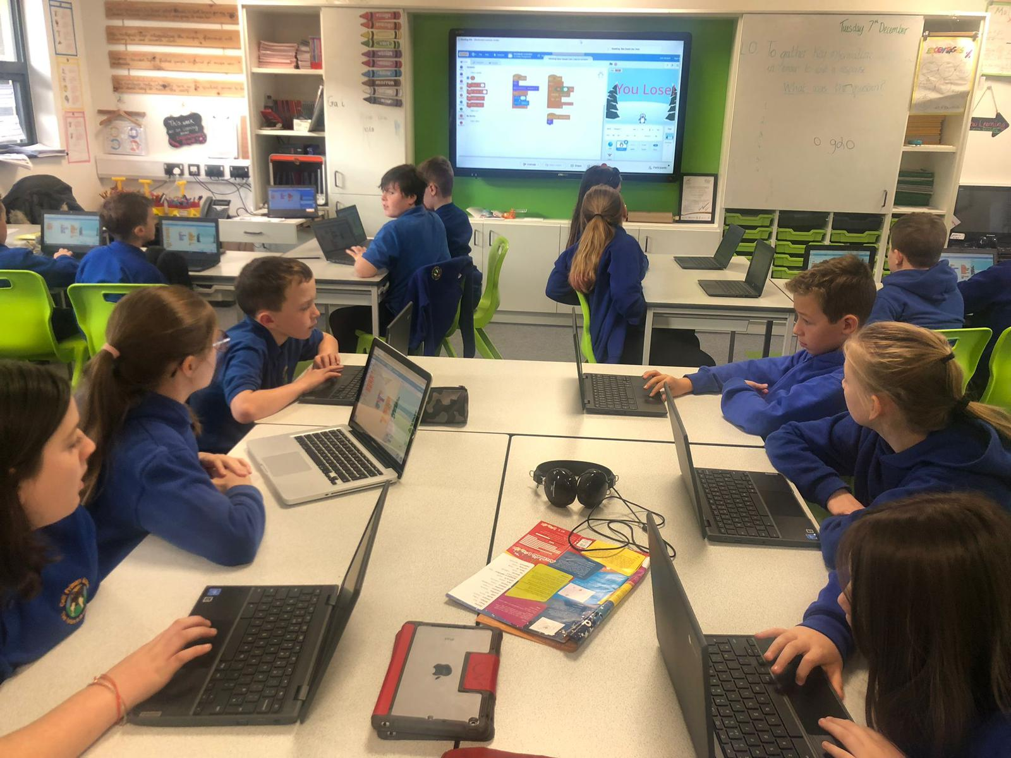
- Football
- Athletics

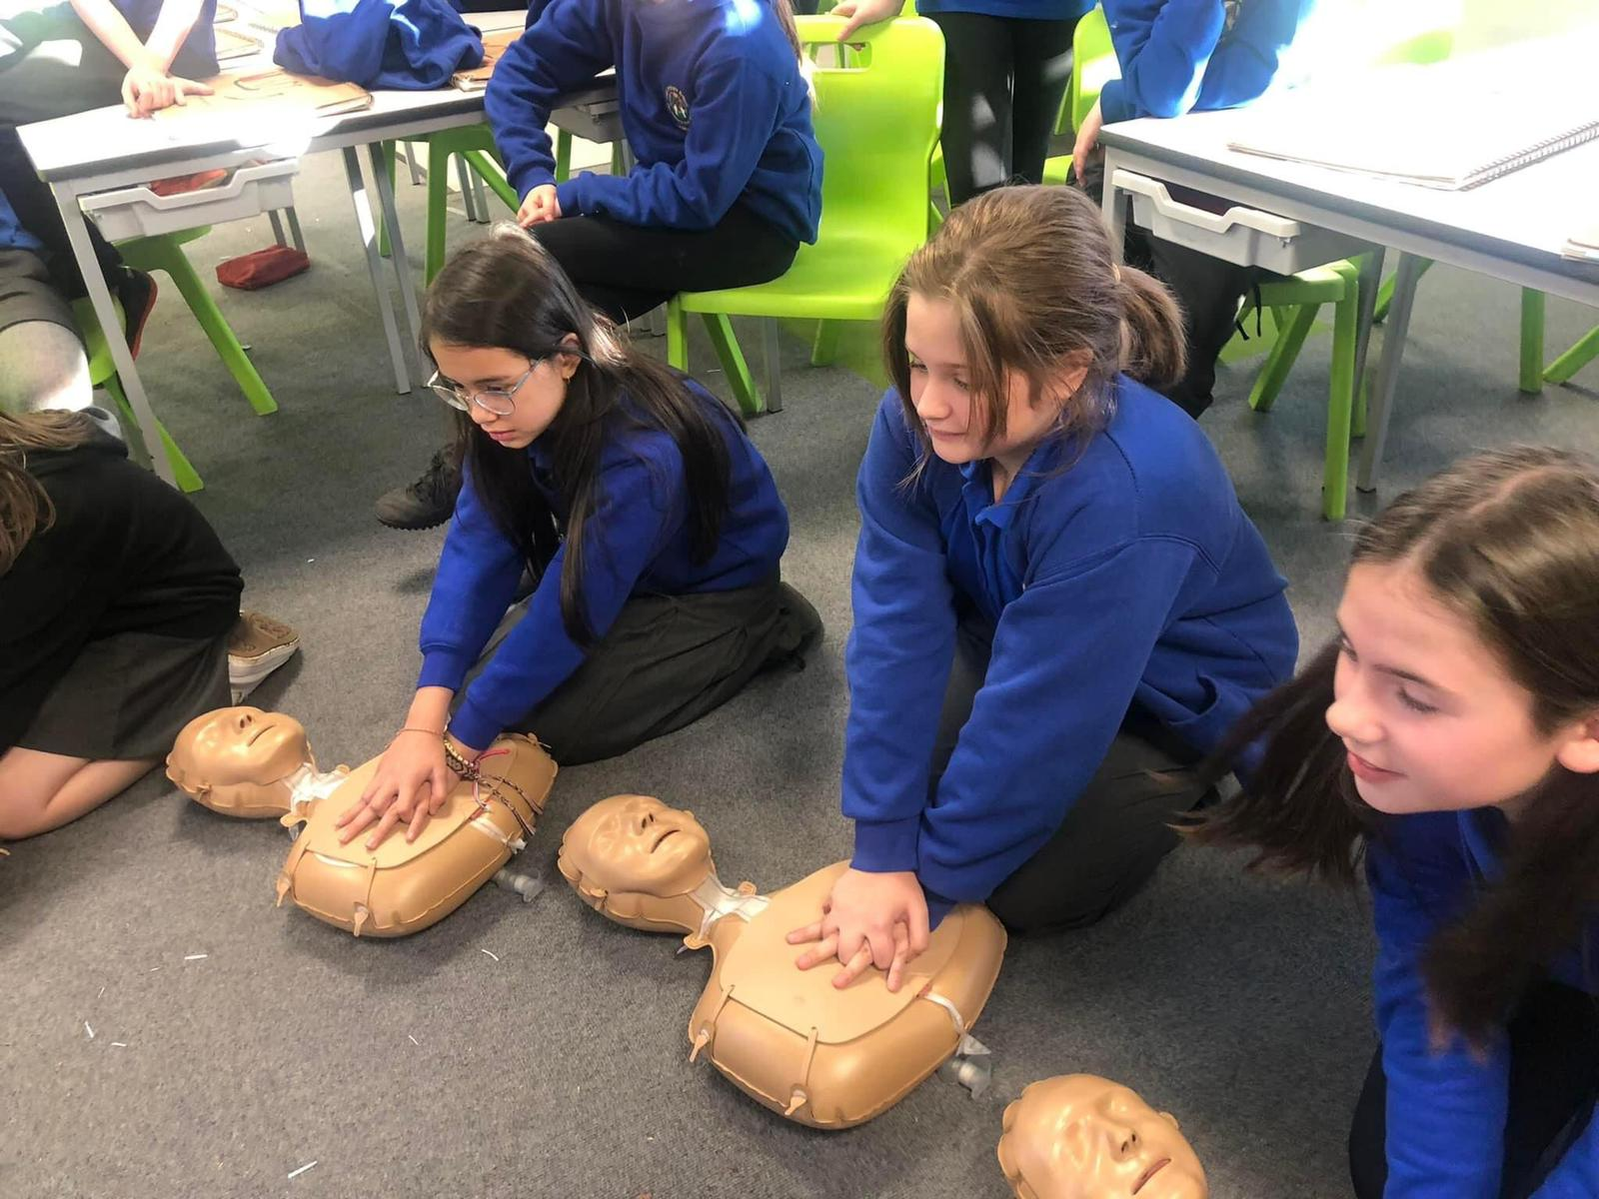

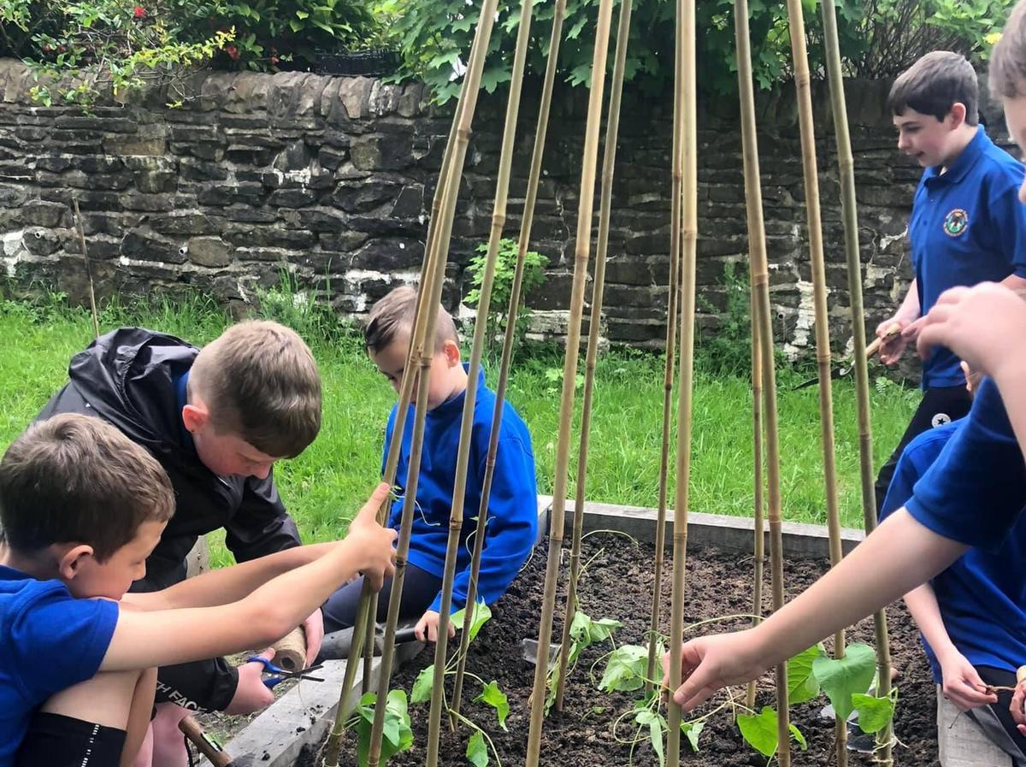

The School day

A senior member of staff or Family Engagement Partner will be present at the main gate to ensure pupils make their way onto the classrooms safely. Staff are in class to welcome children from 8.50am to ensure a prompt start of 9.00am. Breakfast club opens at 8am and children need to be at breakfast club before 8.30am. Break times and lunch times are staggered throughout the day.
Pupils enjoy a full lunch hour. Due to the size of the school, lunch hours are staggered.
They are: Nursery/Reception/year 1: 12.00-1.00pm
Years 2 & 3: 12.00pm – 1.00pm
Years 4/5/6: 12.30pm – 1.30pm

We ask parents/carers to be prompt when collecting their children at the end of the day – school finish times are also staggered.
They are: Nursery/Reception: 3.00pm
Years 1: 3.05pm
Years 2: 3.10pm
Years 3, 4, 5 + 6: 3.20pm

If another adult is to collect a child either temporarily or permanently, we ask parents to contact the school office. If for any reason there is an unavoidable delay, parents are asked to contact the school and wherever possible.

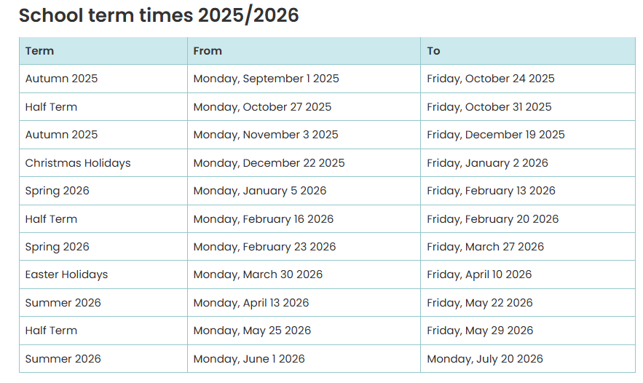
Term times:

Health and safety

The health and safety of all the children in our school are of utmost importance and have arrangements in place to safeguard and promote the welfare of all the children in our care. We recognise that high self-esteem, confidence, supportive friends and good lines of communication with a trusted adult helps to safeguard pupils. The school will therefore continue to maintain an ethos where children feel secure and encouraged to talk through weekly check-ins and restorative approaches.

The school has a robust system of risk assessment in place such to ensure the security of your children such as an electric system to enter the school, locked gates and correct staff to child ratio but recognises the risks outside the school gates must be managed in partnership with good communication. Parents are requested to park responsibly and to avoid parking on the pavement or on the school grounds.

Please assist us by ensuring children only wear stud earrings and appropriate footwear.

In our school the Headteacher, Mrs. Flanary-Davies has overall responsibility for child protection matters and acts as a source of advice and support to other staff. Mrs Adams our Deputy Head Teacher is the Safeguarding lead in her absence. Miss Mathias and Mrs Fraser act as Child Protection officer in her absence. All are level 3 trained.

Our school has a nominated child protection governor, Mrs D Jouvenat, who has to ensure that the school has a child protection policy in place which is consistent with the new All Wales Child Protection Procedures (2008) that all staff in the school must follow where there are concerns or suspicions of child abuse.

Medical Accidents- Please ensure that we are informed about any medical condition relating to your child that is likely to affect your child’s education or general wellbeing in school. School especially needs to be informed if your child would require any emergency medication e.g. epi-pen.
Also please ensure that if your child requires an asthma pump, the school is informed of this and brings their pump into school clearly labeled with their name and class. Asthma pumps are kept to hand in the class for children in Nursery and Reception and centrally stored for pupils in the rest of the school. Forms must be also filled in at reception for Any medication.
At various stages through the school years, children will have their eyesight and hearing tested and a routine dental check is usually carried out. Any concerns raised during these routine checks will result in the offer of an appointment to the relative health department.
If your child becomes ill or has an accident at school it may become necessary to contact you. Please ensure that emergency contact numbers are up to date. Children who have minor accidents at school, usually when falling over at playtime or lunchtime, are tended to by one of the school’s qualified first aiders. These accidents are recorded in the accident book and parents are informed of any significant incident either by means of a note or telephone.
Children will need to bring a note to school to be excused from P.E. lessons and are expected to be well enough to play outside at playtimes and lunchtime.

Equal Opportunities

Gelli Primary School is committed to equality of opportunity for all its pupils, regardless of sex, race, disability , religion or social class. We want all our pupils to achieve their full potential during their time with us.
We believe that all pupils are of equal worth and we place equal value on the abilities, talents and skills of every individual in our charge.
We actively attempt to make all aspects of the school curriculum equally attractive to boys and girls.

(Equal Opportunities Policy available from Headteacher)

Complaints Procedure

The Governing Body has approved the document setting out the arrangements for Rhondda Cynon Taff in respect of the above. The complaints procedure is summarized as follows:-

- Inform class teacher
- Inform Headteacher
- Inform Governing Body

We have a full complaints policy on the website or you can request a paper copy and this document will give you details and contact numbers you may need.

Communication- let’s work together
At Gelli primary we recognise the importance of an active parental involvement between home and school. We encourage parents to help their children with activities that are sent home by the class teacher e.g. reading practice, home tasks. We use SeeSaw as a platform for home learning. Children have individual logins to see and complete homework and the app is free to parents
If you have any concerns you should speak to your child’s class teacher in the first instance. Most concerns can be dealt with swiftly. If you still have issues or concerns you can speak to Mrs. Flanary Davies by phone or in person.
We regularly send home information and newsletters to parents by pupil post, we also use social media, text service, Seesaw and our website to keep you informed of activities and information you may need.
We are looking for parents, carers and aunties, grandparents and uncles to join our Friends of Gelli group to help raise money for our school. New members are always welcome.
When a child enters our school for the first time parents will be asked to sign a Home/School Agreement and a GDPR permissions form
The school has a Parent Council run by
Miss C Mathias and elections are held at the start of every academic year.

Our role models, Our children

We pride ourselves on our standards and believe that children should behave in the way you, as responsible parents would wish them to behave.
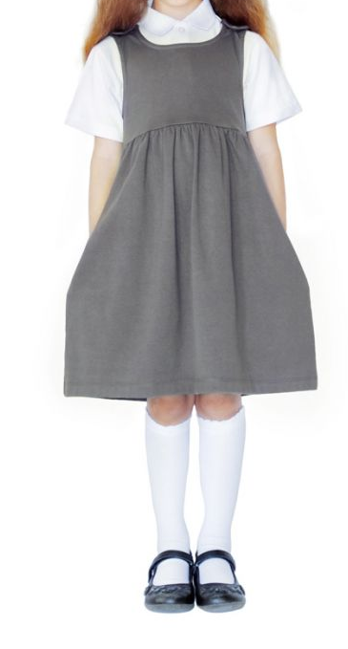
Our expectations:
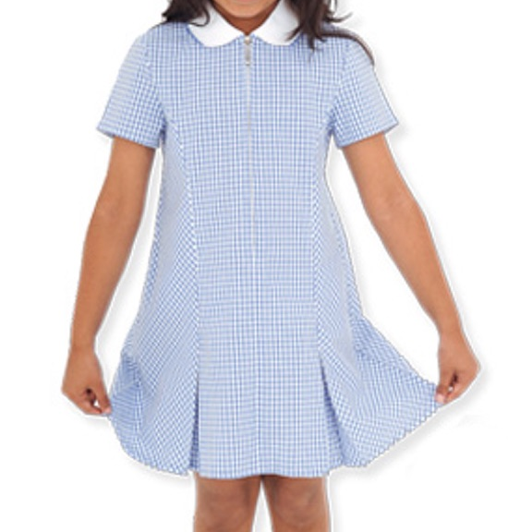
- We encourage good manners and empathy for others
- Children to move sensibly around the school and learning environment,
- Pupils should not bring any sharp implements such as penknives, compasses or scissors.



If a child does display unacceptable behavior parents are notified. The school has a transparent graduated response to continued disruptive behavior and we will always involve the family in this process.

If the unacceptable behavior still persists, the onus to exclude us now is the absolute responsibility of the Headteacher and Governing body.

School Uniform.

It is very important to maintain the standard of dress as this reflects attitudes to school.
Examples:
Gray Skirt/ Pinafore dress/ trousers/ blue joggers/ blue jumpers/ cardigan/hoodie and black shoes.

PE: plain white T-shirt, Trainers

School Meals
Cooked school dinners are provided in our canteen and are made fresh daily. School meals are Free.

RCT School Dinner menu is available online and below!
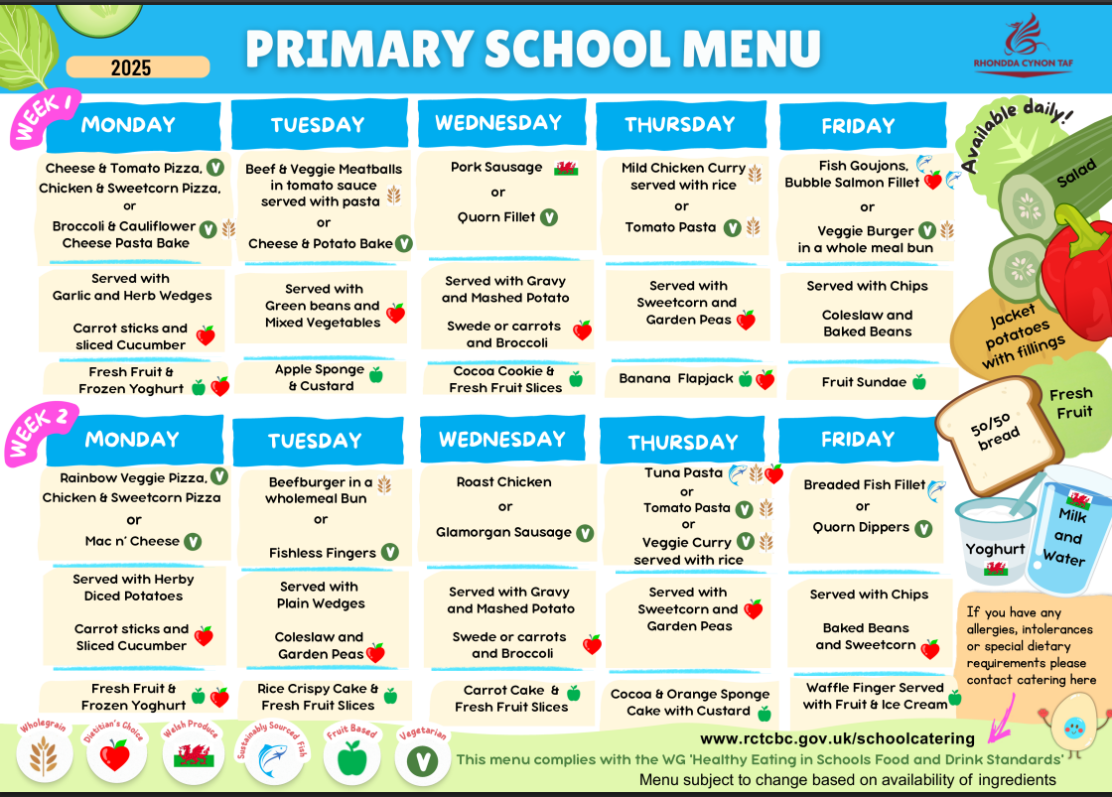

The Senedd
We have a Senedd in our school which enables all children to have a voice in the running of the school. All junior school children are part of the Senedd and are members of one of our Senedd groups:
● Green Team (Eco council)
● Criw Cymraeg (Welsh language development)
● Change Makers
● Health and Wellbeing
● Digital Leaders
● ECadets
● Rights and Values
Each group has an elected Minister, Ministers can then stand for election to be First Minister.
Ministers meet regularly with the leadership team of the school to be involved in decision making and ensure pupil voice is represented.

Head Lice

Each year we have cases of head lice in school. The school nurse no longer visits school to inspect children’s hair so parents are asked to do this at home on a regular basis. Parents are informed by letter or text if there are head lice in your child’s class and we would encourage every parent to check and treat their child’s hair as appropriate. Treatment is always free at all local pharmacies.

Keeping in Touch


The School Website:

www.gelliprimary.org.uk

Facebook
We have three pages:
Gelli Primary –information only
Gelli Primary Parents-Closed page, please ask to join. Photos are always posted to this page
Friends of Gelli-run by the Friends of Gelli group.
SeeSaw- this is where you will find newsletters and homework. Class teachers will also send notifications through this.

MyChildatschool app- Messages, event info, attendance information for your child and school announcements

MyChildAtSchool

______________________________________________________

We know you will love it in our school.

“The school feels like home, we get to see our friends everyday”
- Pupil in year 5

“This school is the best”
- Pupil in year 6

