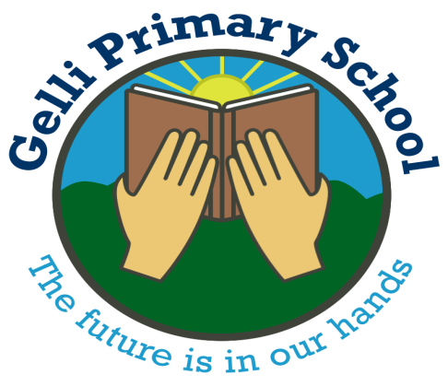
Gelli Primary School
Ystrad Road
Ystrad
RCT
CF41 7PX
01443 435311
Admin@gelliprimary.rctcbc.cymru

Parent/Guardian

I hope this letter finds you well. As part of our ongoing commitment to improving communication between the school and home, we are pleased to introduce My Child at School (MCAS) app. This app will serve as a more efficient and streamlined way for you to access important information about your child’s education.


Through the MyChildAtSchool app, you will be able to:-

- View attendance records and school reports

- Report Student absence
MyChildAtSchool

- Receive real-time updates and notifications from the school.

- Access key documents such as timetables and exam schedules.

- Update personal data for you and your child directly from the app.

We believe that this move will enhance the way we engage with parents and provide a more user-friendly and transparent way to stay informed about your child’s academic journey.

The My Child At School (MCAS) app is available on the Apple store and the Google

Please follow the below steps in order to access MCAS ‘My Child at School’ parent app-

- Download the app (Logo above) type in ‘My Child at School’ app
- Go to your emails (the one on the school system) and find the email from ‘Gelli Primary School’
- Click ‘HERE’ on the email which will send you to the MCAS Website
- Enter your chosen Password and click ‘create password’
- You will then be able to log into the app with your email address (the one you provided to school) and the password you just created. Then you will be asked to create a 5 digit pin.
Please let us know if you have any issues with logging into the app.
Many Thanks
Mrs Flanary-Davies
Headteacher

